John Milton, one of the most educated men in western history, appropriated the
Bible, Homer’s Iliad and Odyssey, Virgil’s Aeneid, and hundreds of other classical
texts when writing his poetry and prose.

And since Milton’s death, hundreds of artists, writers, musicians, film directors, and even video game designers have appropriated his themes, language, and imagery for their own work. But what is Milton doing in these other artists’ work? As Gregory Semenza and Laura Lunger Knoppers ask in the introduction to Milton and Popular Culture, “why quote Milton, instead
of Shakespeare or Charles Dickens or Jane Austen? . . . Is ‘Milton’ an authority
to be imitated or challenged, endorsed or refuted, perhaps by using his own
materials?” (4).

See Milton appropriations, here.

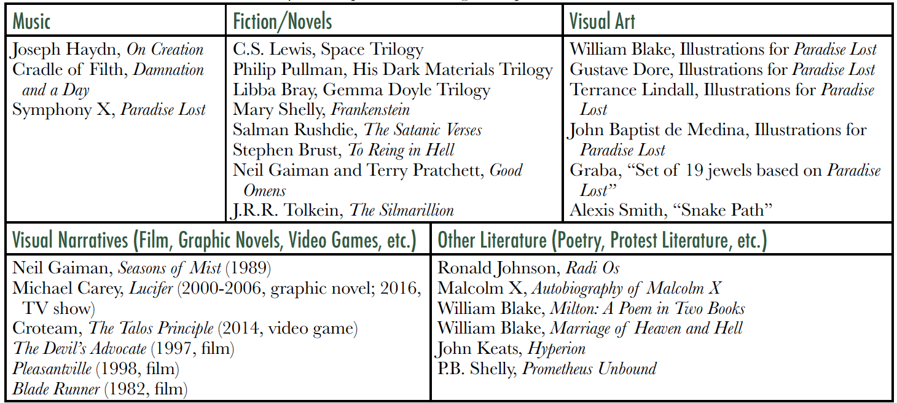

Please choose an appropriation of Milton’s work and ask yourself Semenza’s and Knoppers’ question. Then do the following:

- Begin by helping your reader envision and understand the appropriation: include at least 2-3 images, film stills, or links to your chosen “hypertext”
- Briefly summarize the hypertext in 1-2 paragraphs
- Explain how Milton’s work is adapted or appropriated – does he intimidate or inspire? Include at least three quotes from Milton’s work.
- Your essay should be more than a comparison: it should have a central claim. The claim can stem from Semenza’s and Knopper’s question or it can
- Be sure to cite both the hypertext and Milton. No outside sources are necessary.

