Galya ____
Dr. Higinbotham
Shakespeare
28 April 2022
The Spectrum of Othered Responses:
Shakespeare’s Marginalized Characters and the Social Sciences
We have all been there at some point or another. Often, the stakes are low: getting picked last for a sports team, not getting invited to a social gathering, or being excluded or ignored from a conversation. Other times, the stakes are much higher: being denied rights or citizenship, experiencing discrimination, or becoming completely excommunicated or canceled from society. No matter the form, marginalization and ostracism hurt – they cause sadness, loneliness, or anger. After all, humans are social creatures; we depend upon each other, develop societies together, and greatly value connection with one another. With such an emphasis on social cohesion, ostracism, exclusion, or marginalization become deeply painful and fundamentally threatening experiences. In fact, researchers have found that ostracism triggers the same brain region as physical pain (Eisenberger, Lieberman, and Williams). As such, when an individual is excluded or marginalized from a larger group, this pain can drive them to react in particular ways.
With such an impact on human relations, emotions, and well-being, ostracism or social exclusion have been extensively studied through a number of different fields, from philosophy to art to social science. One playwright who focuses extensively on the experiences of social exclusion is William Shakespeare. Throughout both his comedies and tragedies, Shakespeare explores in-group and out-group dynamics and the way different characters are marginalized within communities. From villains like Don John in Much Ado About Nothing to heroes like Antonio in The Merchant of Venice, Shakespeare explores the range in which different characters other and become othered, from complete rejection by society to discrimination to slight isolation. While many scholars have explored various ostracized characters within Shakespeare’s plays or the series of events that lead to their marginalization, few have closely examined these players’ reactions to being othered.
Responding to this gap in scholarly research, in this paper, I will examine the reactions of various marginalized or othered characters, pointing out trends that appear across Shakespeare’s plays. Drawing on characters from three Shakespearean comedies – Much Ado About Nothing, The Merchant of Venice, and Twelfth Night: Or, What You Will – I will propose a model to help examine the reactions and behaviors of various ostracized characters within Shakespeare’s works. Bridging between the humanities and sciences, I shall also explore how this model can connect to modern scientific theories about the effects of and human responses to ostracism.
First, I will delve into literary studies, outlining and exemplifying the proposed model, the Spectrum of Othered Responses (SOR). Next, I will connect the model to modern and scientific understandings of ostracism. Finally, I will synthesize these ideas within a specific case study, analyzing the character, ostracism, and response of Malvolio from Twelfth Night: Or, What You Will.

- Proposed Model: The Spectrum of Othered Responses (SOR)
Upon examining Shakespeare’s portrayal of ostracism and othering within Much Ado About Nothing, The Merchant of Venice, and Twelfth Night: Or, What You Will, one can begin to identify certain patterns of character responses or behaviors. These trends can be arranged as a spectrum according to the following model:

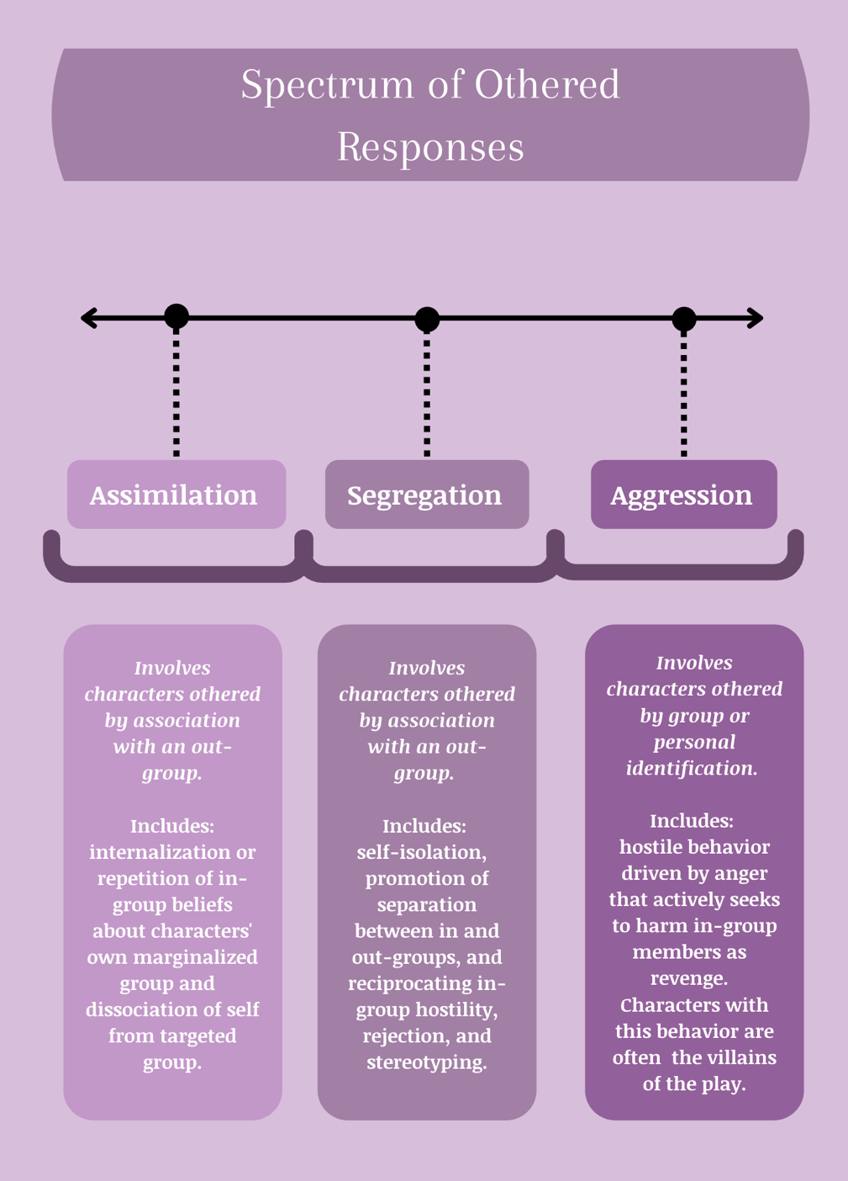
Fig. 1. Spectrum of Othered Responses Model
Within this Spectrum of Othered Responses, the behaviors of ostracized characters fall somewhere within three distinct sections: assimilation, segregation, or aggression. While the responses of characters can range in specific actions or behaviors depending on the character, context, and situation, they can be described in terms of these general trends.
As the first section of the spectrum, Assimilation represents the least confrontational trend of character responses to marginalization. Revolving around conformity and acceptance, this response to ostracism is best exemplified by the behavior of Jessica in The Merchant of Venice. A Jewish woman living within an Antisemitic community, Jessica internalizes hatred against Jews. She yearns to assimilate to the Christian in-group, as depicted by her tumultuous thoughts:
Alack, what heinous sin is it in me
To be ashamed to be my father’s child?
But though I am daughter to his blood,
I am not to his manners. O Lorenzo,
If thou keep promise, I shall end this strife,
Become a Christian and thy loving wife.
(2.3.16-21)
Ultimately, driven by her experiences of marginalization, Jessica runs away from home, steals from her father, marries a Christian, and converts to Christianity.
As the middle section of the spectrum, Segregation increases in confrontationality yet does not reach outright malicious behavior. One of the best examples of Segregation responses within Shakespeare’s plays is Shylock’s behavior within The Merchant of Venice. Though he is Jessica’s father, Shylock responds to Antisemitism very differently, frequently insulting Christians just as they insult Jews. Through statements like, “I will not eat with you, drink with you, nor pray with you,” Shylock actively promotes the segregation of the two religions, rather than embracing Christian beliefs (1.3.35-49).
Finally, as the last section of the spectrum, Aggression is the most violent and confrontational response to ostracism. Examples of such behavior can be seen within Don John from Much Ado About Nothing. A bastard ostracized by society, Don John yearns to dishonor and destroy his legitimate brother, Don Pedro. He responds to marginalization with violence and vengeance, declaring, “I had rather be a canker in a hedge than a rose in his grace, and it better fits my blood to be disdained of all than to fashion a carriage to rob love from any” (1.3.25-8). Disillusioned by social exclusion, Don John rejects society altogether, responding in anti-social behavior meant to sabotage the protagonists of the play. This situation, as well as those of Jessica and Shylock, only serve as a few examples within Shakespeare’s plays that reflect the different sections of the SOR. Many other character responses could be described and analyzed through this spectrum; for example, future studies could apply this model to figures like Viola, Hamlet, or King Lear. However, the scope of this essay serves only to introduce and exemplify the SOR model itself.
I am not claiming that the different elements of SOR are distinct types or categories. This model is intentionally and specifically presented as a spectrum due to the fluid nature of characters, responses, and levels of ostracism presented within Shakespeare’s plays. As the book Shakespeare and Outsiders describes, ostracism is “fluid and ambiguous…, because it is a position that can be moved into and out of, towards which other characters (and the audience) can have many different attitudes. It is a relative identity and not a fixed position” (Novy 1). Marginalized characters can thus become accepted and accepted characters marginalized, while others may exist within a murky in-between. In The Merchant of Venice, for example, the merchant Antonio exists within the in-group, being a well-respected, beloved man who is defended by others, yet by the end of the play, left conspicuously alone onstage.
Moreover, just as characters can move in and out of ostracism, their responses to being marginalized can fluctuate, moving along the spectrum throughout different parts of the play. Shakespeare’s characters are not static beings, existing solely in one category or another; they move in and out of social favor, and their reactions to marginalization can fluctuate and change, depending on the nature of the situation at hand. For example, although Shylock can be described through the Segregation section of the SOR, he also moves closer to Aggression throughout The Merchant of Venice as he yearns to revenge upon and actively harm Antonio. The nature of the SOR as a spectrum therefore highlights this level of fluidity, enabling characters to move back and forth across these different sections as well as in and out of social favor.

- Connections to Science: The Temporal Needs-Based Theory
Beyond literary and Shakespearean studies, the SOR also connects to the social sciences, informed by contemporary understandings of behavioral responses to ostracism through the Temporal Needs-Based Theory. According to this model, the experience of ostracism threatens four basic human psychological needs: belonging, self-esteem, control, and meaningful existence. This threat produces high levels of distress and pain, stimulating responses in three stages: immediate/reflexive, coping/reflective, and long-term resignation (Williams and Nida 71). This paper will focus on the second stage, where “ostracized individuals reflect on the meaning and relevance of the ostracism experience and, if it merits attention, will think and act in ways that fortify the threatened need(s)” (Williams and Nida 72). It is especially in this stage where a range of different behaviors occur, as context and personal factors influence which needs a person seeks to regain.
If reintegration and inclusion are perceived as possible, ostracized people will attend to their needs for belonging and self-esteem first. As such, these individuals will engage in extremely pro-social behavior, becoming more attentive to social information, conforming to group attitudes, and seeking to maintain and develop social connections (Williams and Nida 72-3). This pro-social response corresponds with the first section of the SOR, Assimilation. Characters like Jessica see potential for inclusion within society and thus reject their ostracized groups. As such, they conform to in-group stereotypes to attend to their needs for belonging and self-esteem.
If reintegration is not perceived to be feasible, individuals will then seek to fortify their needs for control and meaningful existence (Williams and Nida 73). When driven by anger (as opposed to sadness), this coping response produces more hostile behavior (Chow et al.). Finally, if individuals cannot attend to any of their threatened needs, they will lash out through significant aggression and anti-social behavior (Williams and Nida 73; Chow et al.). These two anger-oriented coping responses are reflected within the Aggression section of the SOR. Characters with anti-social behavior, like Don John, become hostile in order to regain a sense of control, or otherwise lash out as a result of their inability to attend to their threatened needs. Finally, the Segregation section of the SOR represents a middle point between these pro- and anti-social coping mechanisms. The Temporal Needs-Based Framework and its foundations within emotion thus overlap with the proposed SOR, as the latter model is mapped across a spectrum of pro- to anti-social behavior:

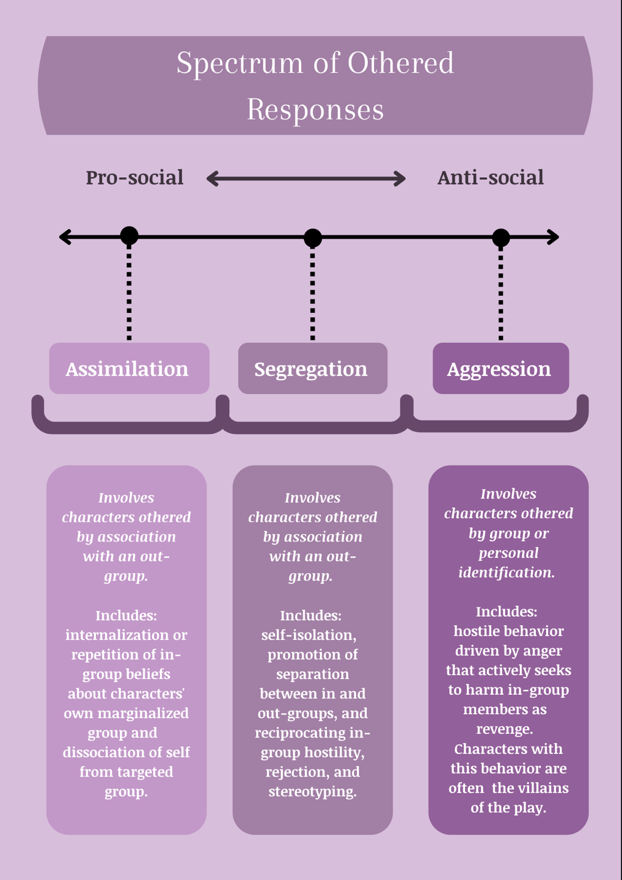
Fig. 2. SOR with respect to the pro- and anti-social distinction
With the SOR and its foundations in the Temporal Needs-Based Theory, one can re-examine Shakespeare’s works through a new lens. As such, this paper will integrate and demonstrate these ideas through the case study of Malvolio from Twelfth Night: Or, What You Will.

- The Case of Malvolio
Steward of the countess Olivia of Illyria, Malvolio is a man who likes order and control. He takes on a somber semblance and disapproves of the drunken merrymaking and festivities that most of the members of Olivia’s household perform (apart from Olivia herself). As such, Malvolio views himself as morally superior, frequently showing his disapproval through lines like:
My masters, are you mad? Or what are you?
Have you no wit, manners, nor honesty but to
gabble like tinkers at this time of night? Do you
make an ale-house of my lady’s house, that you
squeak out your coziers’ catches without any mitigation
or remorse of voice? Is there no respect of
place, persons, nor time in you?
(2.3.86-93)
Malvolio frequently threatens Sir Toby and Sir Andrew Aguecheek, two gentlemen of higher rank, in attempts to suppress their rowdy behavior. Even in his very first appearance in the play, the steward already expresses disdain, insulting the Feste the Fool by calling him a “barren rascal” (1.1.82). As such, Malvolio is hated by all members of the household except Olivia and is denounced as a Puritan for his snobbish behavior (2.3.139).
And yet, behind this somber sobriety, Malvolio yearns for greater power and status. He hopes to marry Olivia, who is well above his rank, not out of love but out of desire for control; the steward dreams of having power over Sir Toby and the other rowdy revelers (2.5.34-80). Through his behavior, Malvolio distances himself from others, relying on the “presumptuous belief that he lives in a sphere above and beyond ordinary human relations” (Slights 543). Though he hides his desires behind a “Puritan” comportment, other characters of the household see through his façade, considering the steward not only a stuck-up prick, but also a “duplicitous fraud and phony” (Hobgood 4). As aptly stated by author David Carroll Simon, Malvolio becomes “a sitting duck… but also a preening one – and so Maria [a gentlewoman and one of the revelers] easily persuades him to play the peacock” (441). In other words, Malvolio becomes the target of ostracism and marginalization through the form of a vicious prank.
Through an intentionally crafted letter, the other members of the household trick Malvolio into believing that his countess is in love with him, inflating his ego and instructing him behave erratically. While Malvolio believes this change in behavior – which includes wearing cross-gartered yellow stockings, smiling outrageously, and insulting other people - will win him Olivia’s favor and thus her power, it only serves to expose his private, un-Puritan character into the public sphere (Hobgood 5). In a humiliating act, Malvolio inadvertently reveals his power-hungry ambitions, which ultimately lead to his incarceration and isolation as he is declared to be insane.
Locked away in a dark cell, Malvolio is shoved into reality and forced to realize his own vulnerability. Author Hobgood explains: “these shameful experiences reveal his dreams of social advancement to have been just that, dreams,” leading to a great fall from an imagined stature (7). The once-aloof character, independent of all forms of reciprocity, is now reduced to perform “a demonstration of dependency so humiliating,” as the isolated Malvolio is forced to beg Feste for a few simple items (Slights 544). Shamed, revealed to be a phony, declared insane, and locked away in a dark cellar, Malvolio has certainly “been most notoriously abused” (5.1.402). Having experienced such a level of viciousness, he can no longer see himself reintegrating into the dominant group, especially when his abusers express little to no sympathy or remorse for their actions. Denied acceptance, isolated, and literally buried, Malvolio cannot address his need for belonging or self-esteem, and thus turns to strengthen his need for control. As Hobgood explains, Malvolio attempts to manipulate his shameful experience into a different narrative, one that shames his abusers instead by forcing them to recognize their accountability (8-10). Through this action, the steward attempts to regain control of the situation, narrative, and his own body. Yet this appeal falls flat and ultimately leads to Malvolio’s famous declaration: “I’ll be revenged on the whole pack of you!” (5.1.401). Unable to address any of his threatened needs and further angered by the utter injustice of his situation, Malvolio responds hostilely, reverting to the anti-social behavior described within the Aggression section of the SOR. He resorts to violence and confrontation, rejecting society and seeking revenge rather than social integration or segregation.

- Concluding Thoughts
As this case study and paper have demonstrated, one can employ the SOR to conduct analyses of characters within Shakespeare’s plays, determining where they fall along this proposed spectrum throughout their appearance onstage. While not all characters or behaviors may fit neatly into these proposed sections, the SOR is nevertheless a useful framework, revealing important trends about Shakespeare’s marginalized characters, as well as the variety of responses a person can have when being ostracized. Further, this spectrum is valuable in that it opens the door to further research surrounding characters’ responses to being othered. Future studies can examine this framework in greater depth, applying this model to analyze the patterns of behavior of different characters within Shakespeare’s plays. Moreover, future work can explore whether such trends appear in Shakespeare’s tragedies and sonnets as well as his comedies, or even within plays and novels beyond this playwright’s works.
The Spectrum of Othered Responses framework delivers a new lens to explore marginalized character behaviors within Shakespeare’s plays, providing further insight into the range of human coping mechanisms. This lens situates characters’ responses within the context of other marginalized characters, as well as contemporary scientific understandings of ostracism and coping mechanisms. In a world where othering and marginalization occur frequently, analyzing ostracism and the range of coping responses that exist is essential. By identifying patterns and naming the effects of social exclusion, one can break down and situate the processes around marginalization, thereby removing its mystery or fear. Such identification enables us to better understand ostracism and its negative effects, as well as the responses it can produce and the way these reactions are depicted in literature. Through such understanding, we can begin to address ostracism more effectively, working to prevent social exclusion within our society today while also mitigating violence, aggression, or anti-social responses. Finally, beyond the macroscopic scale, this work can also help us reflect on our own personal experiences with ostracism and marginalization. Whether we are getting excluded from a conversation or experiencing blatant discrimination, we can use the SOR lens to stop and think. How will we choose to react, and why?

Works Cited
Eisenberger, Naomi I., Matthew D. Lieberman, and Kipling D. Williams. “Does Rejection Hurt? A fMRI Study of Social Exclusion.” Science, vol. 302, no. 5643, 2003, pp. 290-2.
Chow, Rosalind M., et al. “Excluded Emotions: The Role of Anger in Antisocial Responses to Ostracism.” Journal of Experimental Social Psychology, vol. 44, no. 3, 2008, pp. 896-903.
Hobgood, Allison P. “Twelfth Night’s ‘Notorious Abuse’ of Malvolio: Shame, Humorality, and Early Modern Spectatorship.” Shakespeare Bulletin, vol. 24, no. 3, 2006, pp. 1-22.
Nida, Steve A., and Kipling D. Williams. “Ostracism: Consequences and Coping.” Current Directions in Psychological Science, vol. 20, no. 2, 2011, pp. 71-75.
Novy, Marianne. Shakespeare and Outsiders. Oxford UP, 2013.
Shakespeare, William. Much Ado About Nothing, edited by Barbara A. Mowat and Paul Werstine, Simon & Schuster Paperbacks, 1995.
———. The Merchant of Venice, edited by edited by Barbara A. Mowat and Paul Werstine, Simon & Schuster Paperbacks, 2010.
———. Twelfth Night: Or, What You Will, edited by Barbara A. Mowat and Paul Werstine, Simon & Schuster Paperbacks, 2019.
Simon, David Carroll. “Vicious Pranks.” Studies in Philology, vol. 116, no. 3, 2019, pp. 423-50.
Slights, Camille. “The Principle of Recompense in Twelfth Night.” The Modern Language Review, vol. 77, no. 3, 1982, pp. 537-46.

