January 21, 2021

Dear college students at Burruss,

It’s week 2! I’m really looking forward to reading your reflections on William Zinsser’s classic book, On Writing Well. And I’m also looking forward to collecting your student contracts, and answering any questions that you send my way.

I these same William Zinsser chapters in my Emory classrooms, and one thing that surprises undergraduate students is his emphasis on simplicity. Zinsser teaches us to eliminate the “clutter” from our writing. My Emory students believe that to sound “academic” they have to write in an inflated, snobbish, complicated way. “If it’s simple, it’s not academic, and I won’t sound smart” they worry. But you should always write what you would actually want to read. And let’s be honest: no one wants to read overly-complicated, opaque, dense prose. We want to be able to understand the message without a lot of work.

This simplicity doesn’t mean everything is written in short, basic sentences, but it does mean that you work hard to ensure what you’ve written is clear.

Along with this week’s reading, I thought I’d include an article I published in the Atlanta Journal Constitution last summer, so you can get a sense of what our classes are like when they will be once again in person. Was I always clear in the article? How might you critique me? Could I have been simpler?? I’m interested in your thoughts.

For this week, read the famous writing professor Wayne C. Booth’s essay, “Boring from Within: The Art of the Freshman Essay.” Then write your first “précis” (pronounced pray-see), the highly-structured four-sentence summary of the piece. Remember you have instructions on how to write both reflections and précis in your first packet.

Don’t be afraid of making mistakes. They are how we learn. As long as you keep doing the work, you will succeed! The only way to fail is to stop trying.

I will collect your précis on Wayne Booth next Friday, January 29. And you’ll also get my feedback on your Zinsser reflections. Never hesitate to send me any questions. And may we all be vaccinated soon, so we can get back to in-person classes.

I wish you guys so much more than luck. Always remember your minds are free.

Kind wishes,
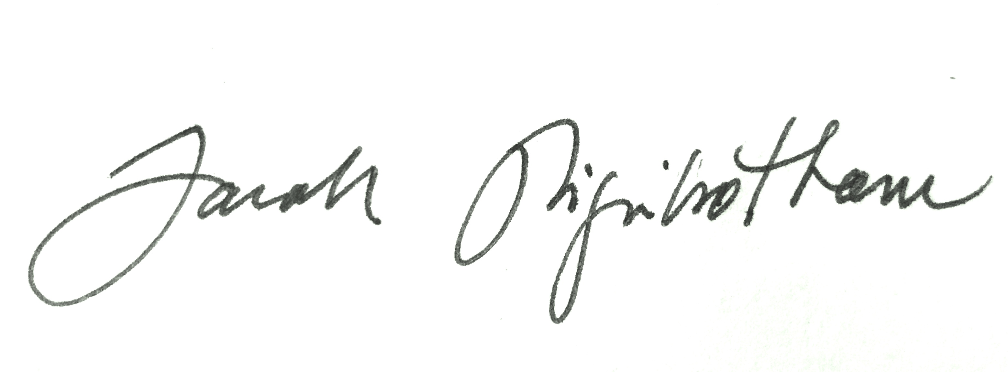
Dr. Sarah Higinbotham

