February 12, 2021

Dear Austin, Larry, Elijah, Drawn, Mack, Buford, Anthony, Xavier, Ryan, Kaden, Devarius, and Zach,

It’s week five of the first course, on Critical Thinking and Writing. And every single one of you has completed every assignment, which quite honestly is very rare in any group of students, especially under these COVID conditions. Rarely does a week go by that I don’t 1) receive several emails from students explaining why they haven’t submitted work or 2) email students asking why they aren’t submitting work. And I teach at Emory, one of the most selective universities on the East Coast. So please know you all are doing exemplary work. Even when you get packets from me printed on the backs of certificates and on notebook paper…

So far in this course, you’ve read and responded to articles and book chapters on writing (William Zinsser, Wayne Booth) and philosophy (Plato, David Foster Wallace, Helen McDonald). What I’ve been trying to do in this first course is give you an overview of the five different subjects you will study in this 10-month class: writing and critical thinking, philosophy, art, history, and literature. So the reading for this week is on art history, and I admit, it’s hard! Well, it’s hard for me. But it’s about one of my favorite artists, Wassily Kandinsky, who is considered the father of abstract art.

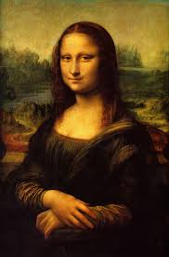
“Abstract” art is composed – to some degree – independent of visual references in the world. So for much of western history, the purpose of art was to accurately represent things and people: kings, queens, vases of flowers, country-sides, mountains. Think of Leonardo da Vinci’s Mona Lisa, to the left here. But abstract art, or “non-objective art,” or “non-representational art” recognized that art is an experience. Abstract artists believe that art is an experience like music, which invites you into the experience and allows you to find the meaning in the work.

One of the most common things people say is that abstract art “isn’t real art.” You might hear people say that abstract art isn’t “about” anything. I think this misses the point: abstract art doesn’t contain recognizable objects, so there is nothing to grasp or hold onto, or judge. This can be confusing. It can be threatening. It can be like… leaving the cave, where everything looks strange and even painful??

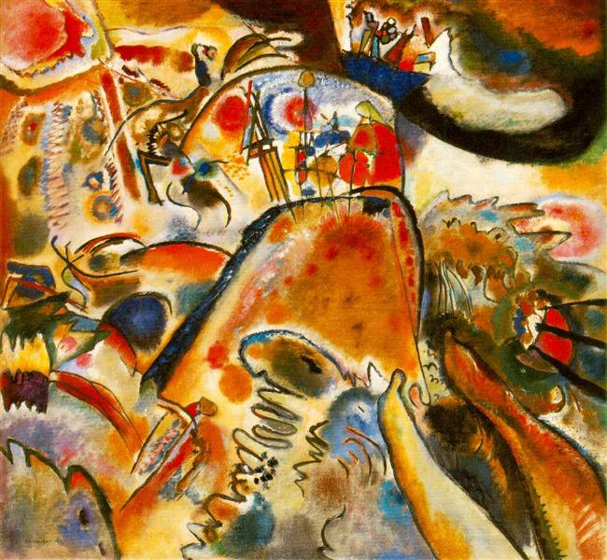
I hope you can be open to Kandinsky’s work and his theory of how art is spiritual, not material. I just gave you the first part of his book, and it’s a translation from his Russian language. If I were you, I would start with the second article, “Kandinsky on the Spiritual in Art and the Three Responsibilities of the Artist,” which is still challenging, but if you read it slowly, underline, write in the margins, and re-read it, I think you begin to understand what Kandinsky was trying to achieve.

I’ve also printed several of Kandinsky’s paintings for you in color. In real life, these canvases are HUGE! And they are stunning! I saw them at the Guggenheim Museum in New York City, and I will admit that until that day in 2012, I had never been very moved by abstract art. But when I first saw Kandinsky’s painting Small Pleasures, I truly had what Kandinsky explains as a spiritual experience. The painting washed over me like a symphony.

For this week, I’m changing your writing assignment. Originally I assigned a précis on Kandinsky, and now that seems a little absurd to me. I think he would resent his art philosophy being condensed into a four-sentence assignment! So instead, please write creatively: I have included an assignment sheet in this packet. I’m asking you to choose one of Kandinsky’s paintings and really stare at it for a long time: an hour. Then imagine a fictional character that the painting is representing and describe that character. It doesn’t have to be human. This is a creative assignment, and one that can’t be “wrong.”

Two confessions: I am not giving you as much feedback this week as I usually do. I’m sorry. I’m behind on everything because of an illness in my family. And, you are supposed to do a peer review on one of the three Emory students’ work (Lola, Aditi, and Ola) but I didn’t receive their work in time to copy it for you. So just do the creative assignment, and I’ll get you their work to peer review next week. Thanks for being patient with me.

I look forward to reading your reflections on “Vesper Flights.” I’ll collect your creative response to Kandinsky’s painting on Friday, February 19.

I wish you guys so much more than luck. Always remember your minds are free.

Kind wishes,
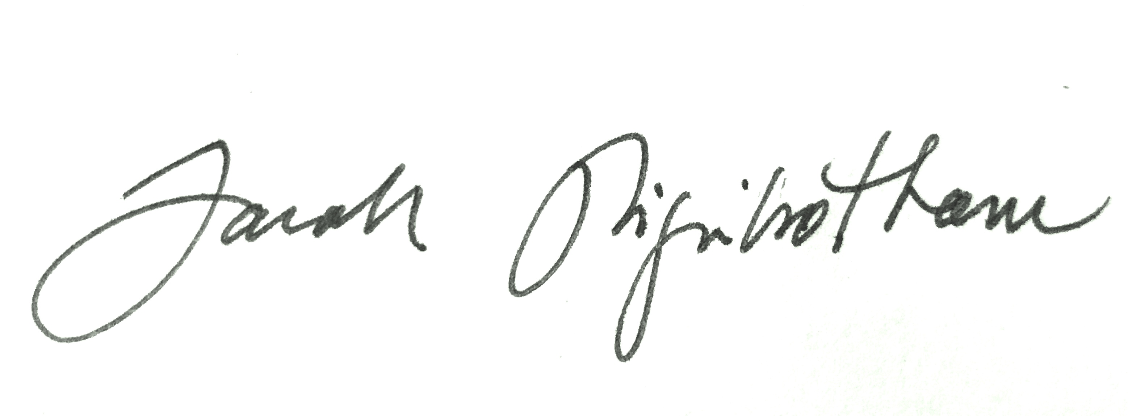
Dr. Sarah Higinbotham

